Name: Shridhar Ajit Ashtikar
Roll No.: B-77

Practical No. 2

Theory

YAAC:
Yacc (Yet Another Compiler-Compiler) is a computer program for the Unix operating system developed by Stephen C. Johnson. It is a Look Ahead Left-to-Right (LALR) parser generator, generating a LALR parser (the part of a compiler that tries to make syntactic sense of the source code) based on a formal grammar, written in a notation similar to Backus–Naur Form (BNF). Yacc is supplied as a standard utility on BSD and AT&T Unix. GNU-based Linux distributions include Bison, a forward-compatible Yacc replacement.
The input to Yacc is a grammar with snippets of C code (called "actions") attached to its rules. Its output is a shift-reduce parser in C that executes the C snippets associated with each rule as soon as the rule is recognized. Typical actions involve the construction of parse trees. Using an example from Johnson, if the call node(label, left, right) constructs a binary parse tree node with the specified label and children, then the rule

expr : expr '+' expr { $$ = node('+', $1, $3); }
recognizes summation expressions and constructs nodes for them. The special identifiers $$, $1 and $3 refer to items on the parser's stack.

Yacc produces only a parser (phrase analyzer); for full syntactic analysis this requires an external lexical analyzer to perform the first tokenization stage (word analysis), which is then followed by the parsing stage proper. Lexical analyzer generators, such as Lex or Flex, are widely available. The IEEE POSIX P1003.2 standard defines the functionality and requirements for both Lex and Yacc.

Some versions of AT&T Yacc have become open source. For example, source code is available with the standard distributions of Plan 9.
Diagram of LEX
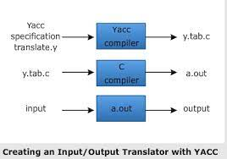
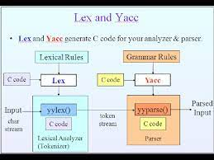

Format for Lex file
%{
C declarations
%}
yacc declarations
%%
Grammar rules
%%
Additional C code
– Comments in /* ... */ may appear in any of the sections.
Rules Section
• Normally written like this
• Example:
expr : expr '+' term
| term
;
term : term '*' factor
| factor
;
factor : '(' expr ')'
| ID
| NUM
;

The Position of Rules
expr : expr '+' term { $$ = $1 + $3; }
| term { $$ = $1; }
;
term : term '*' factor { $$ = $1 * $3; }
| factor { $$ = $1; }
;
factor : '(' expr ')' { $$ = $2; }
| ID
| NUM
;
Aim E1: Write YACC specification to check syntax of a simple expression involving operators +, -, * and /. Also convert the arithmetic expression to postfix.

Program:
Lexical Analyzer Source Code :
%{
#include"y.tab.h"
extern char *yytext;
%}
%%
[0-9]+ {yylval=atoi(yytext); return NUMBER;}
[a-zA-Z] {yylval = yytext[0]; return ID;}
\n return NL;
. return yytext[0];
%%
Parser Source Code :
%{
#include<stdio.h>
#include<stdlib.h>
int yyerror(char* msg);
int yylex(void);
%}
%token NUMBER ID NL
%left ‘+’ ‘-‘
%left ‘*’ ‘/’
%%
stmt: exp {printf(“\nExpression is valid.\n”);
exit(0);}
;
exp: exp ‘+’ exp {printf(“+”);}
| exp ‘*’ exp {printf(“*”);}
| exp ‘-‘ exp {printf(“-“);}
| exp ‘/’ exp {printf(“/”);}
| ‘(‘ exp ‘)’
| NUMBER {printf(“%d”, yylval);}
| ID {printf(“%c”, (char)yylval);}
;
%%
int main(){
printf(“Enter an Expression: “);
yyparse();
}
int yyerror (char *msg) {
printf (“\nInvalid Expression.”, msg);
}
int yywrap(){ return 1;}
Input:
- 15+3-2*9/7
- 12-+23*98
- 25-(3+4)/13*77

Output:
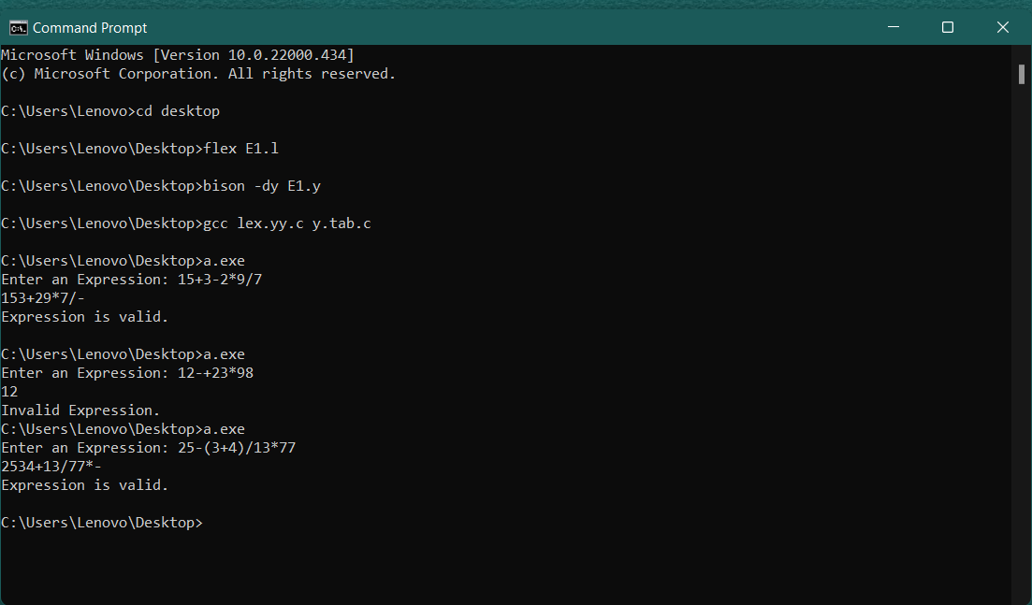

Aim E2: Write a YACC specification to accept strings that starts and ends with 0 or 1

Program:
Lexical Analyzer Source Code :
%{
#include "y.tab.h"
%}
%%
[0][0-9a-zA-Z]*[0] return ZERO;
[1][0-9a-zA-Z]*[1] return ONE;
\n return NL;
. {return yytext[0];}
%%
Parser Source Code :
%{
#include<stdio.h>
#include<stdlib.h>
int yyerror(char* msg);
int yylex(void);
int res=0;
%}
%token ZERO ONE NL
%%
stmt: ZERO NL {printf("Expression starts and ends with 0.\n");
exit(0);}
|ONE NL {printf("Expression starts and ends with 1.\n");
exit(0);}
%%
int yyerror(char *msg){
printf("Expression does not start and end with 0 or 1.\n");
exit(0);
}
void main(){
printf("Enter expression:");
yyparse();
}
int yywrap(){return 1;}
Input:
- 010101010
- 100001
- 00011011
- 1110
Output:
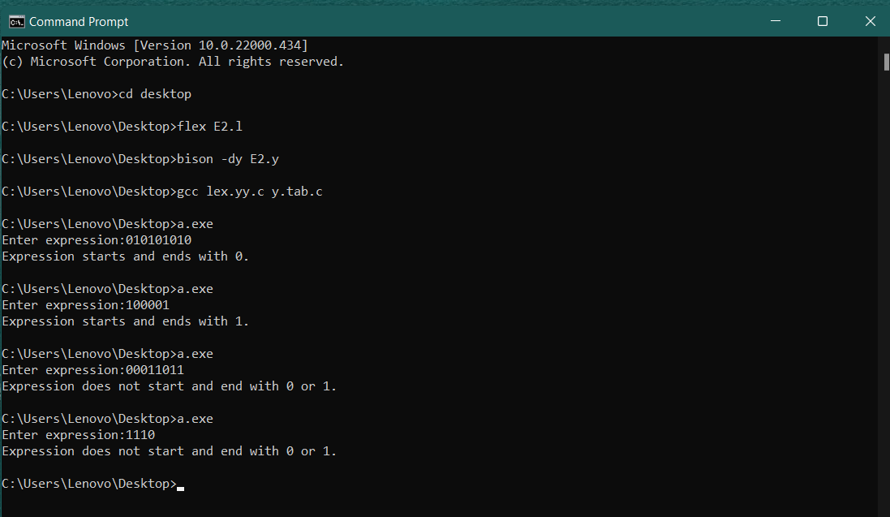

Aim E3: Write a YACC specification to validate the string having general form as below. Construct
a proper grammar for the same and also write the corresponding LEX.:
(a) Any alphabet(s) @ any alphabet + any digit – any digit.
(b) Date
(c) Expression of the form a=b*c

Program:
E3(a) Any alphabet(s) @ any alphabet + any digit – any digit.
Lexical Analyzer Source Code :
%{
#include "y.tab.h"
%}
%%
[a-zA-Z] return B;
[a-zA-Z]+ return A;
[0-9] return NUM;
. return yytext[0];
%%
Parser Source Code :
%{
#include<stdio.h>
#include<stdlib.h>
int yyerror(char* msg);
int yylex(void);
%}
%token A B NUM
%%
stmt: A '@' B '+' NUM '-' NUM {printf("\nExpression is valid.\n");
exit(0);}
;
%%
int yyerror (char *msg) {
printf ("\nExpression is invalid.\n", msg);
}
int main(){
printf("Enter an Expression: ");
yyparse();
}
int yywrap(){ return 1;}
Output:
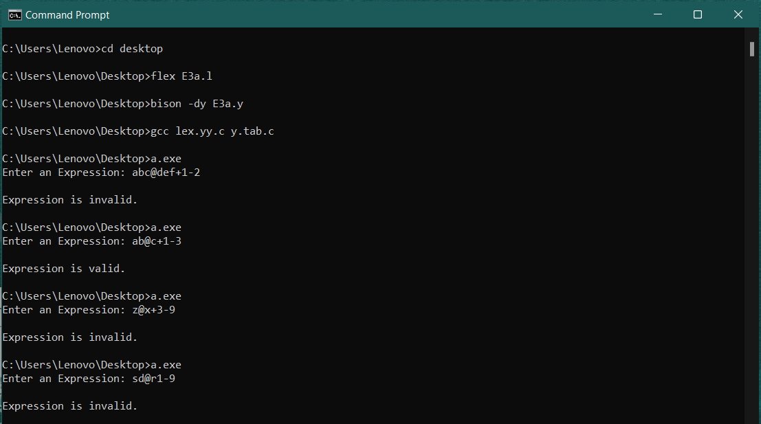

E3(b) Date
Lexical Analyzer Source Code :
%{
#include "y.tab.h"
%}
%%
([0-2][0-9]|[3][0-1])\/(((1|3|5|7|8))|(10|12))\/ return DM1;
([0-2][0-9]|30)\/(((4|6|9))|11)\/ return DM2;
([0-1][0-9]|2[0-8])\/2\/ return DM3;
([1-2][0-9][0-9][-0-9]) return Y;
\n return NL;
. {return yytext[0];}
%%
Parser Source Code :
%{
#include<stdio.h>
#include<stdlib.h>
int yyerror(char* msg);
int yylex(void);
int res=0;
%}
%token DM1 DM2 DM3 Y NL
%%
stmt: DM1 Y NL {printf("Valid Date");
exit(0);}
|DM2 Y NL {printf("Valid Date");
exit(0);}
|DM3 Y NL {printf("Valid Date");
exit(0);}
%%
int yyerror(char *msg){
printf("Invalid Date");
exit(0);
}
void main(){
printf("Enter expression:");
yyparse();
}
int yywrap(){return 1;}

Output:
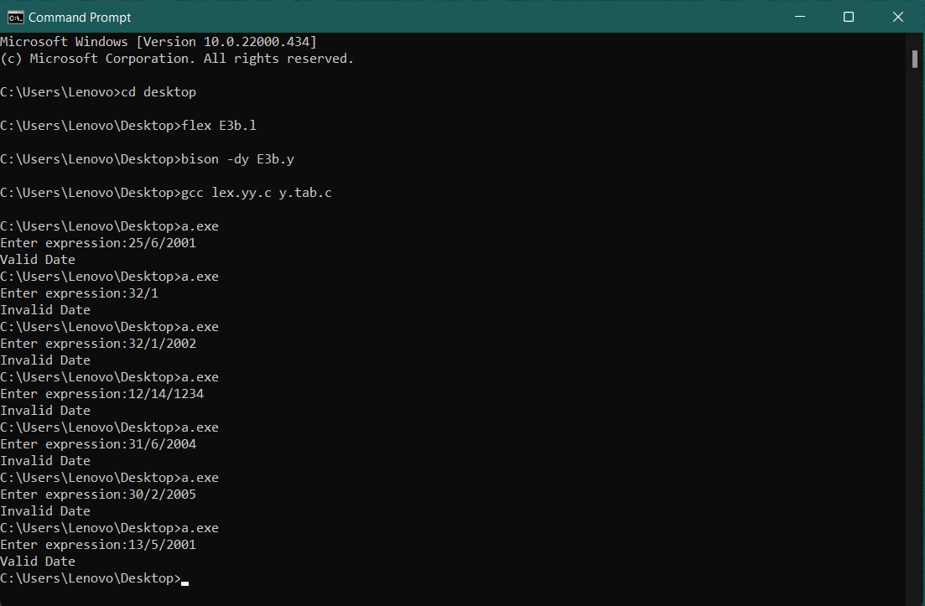

E3(c) Expression of the form a=b*c
Program:
Lexical Analyzer Source Code :
%{
#include "y.tab.h"
%}
%%
[0-9a-zA-Z]+ {yylval = atoi(yytext); return NUM;}
. {return yytext[0];}
%%
Parser Source Code :
%{
#include<stdio.h>
#include<stdlib.h>
#include<string.h>
int yyerror(char* msg);
int yylex(void);
%}
%token NUM
%%
stmt : A {printf("\nExpression is Valid, String Accepted"); exit(0);}
A : NUM '=' NUM '*' NUM
;
%%
int yyerror(char *msg){
printf("Invalid Expression");
exit(0);
}
void main()
{
printf("Enter Expression: ");
yyparse();
}
int yywrap(){return (1);}

Output:
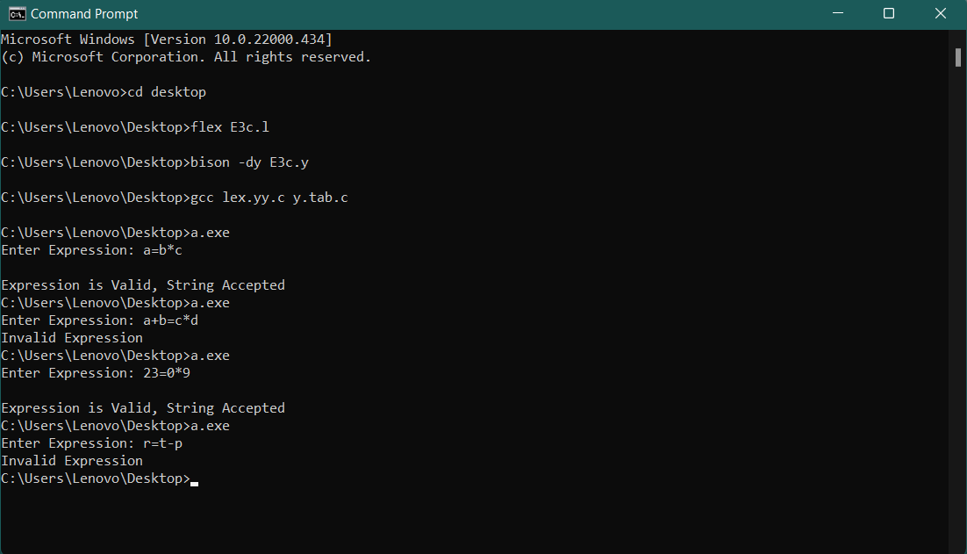

Aim E4: To validate syntax of following programing language construct:
Batch B4: for loop

Sample Input & Output:
The input & output is provided for the if statement. The same is used for do while, while & for loop.

Input: Enter any expression
if (2<3) { Printf(“ b is greater”);}else{ Printf(“ a is greater”);}

Output: The Entered expression is valid

Program:
Lexical Analyzer Source Code :
%{
#include"y.tab.h"
%}
%%
for {return FOR;}
"&&" {return AND;}
"||" {return OR;}
"<=" {return LE;}
">=" {return GE;}
">" {return GT;}
"<" {return LT;}
"!=" {return NE;}
"++" {return INC;}
"--" {return DEC;}
"==" {return EQ;}
"(" {return LPAREN;}
")" {return RPAREN;}
"{" {return OB;}
"}" {return CB;}
[a-zA-Z_][a-zA-Z_0-9]* {return ID;}
[0-9]+ {return NUM;}
. {return yytext[0];} /* return the character itself */
%%
Parser Source Code :
%{
#include<stdio.h>
#include<stdlib.h>
#include<string.h>
int yylex(void);
int yyerror(char* msg);
extern char *yytext;
%}
%token ID CMP FOR LPAREN RPAREN OB CB NL NUM LT GT EQ LE GE NE AND OR INC DEC
%start prg
%%
prg : stmt NL
;
stmt: FOR LPAREN exp RPAREN OB code CB {printf("Valid syntax\n"); exit(0);}
;
exp : E relop E
| E
;
relop : LT
| GT
| EQ
| LE
| GE
| NE
;
code : E ';'
| code E ';'
;
E : ID '=' E
| E'+'E
| E'-'E
| E'*'E
| E'/'E
| E'^'E
| '('E')'
| ID
| NUM
| ID INC
| ID DEC
;
%%
int yyerror(char *msg)
{
printf("Invalid syntax\n");
return 0;
}
void main()
{
extern FILE *yyin;
yyin = fopen("E4input.txt","r");
yyparse();
}
int yywrap(){return 1;}

Input:
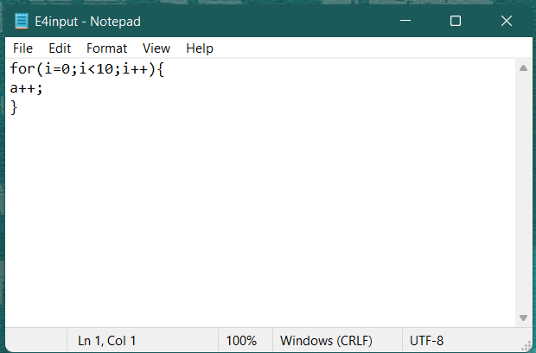
Output:
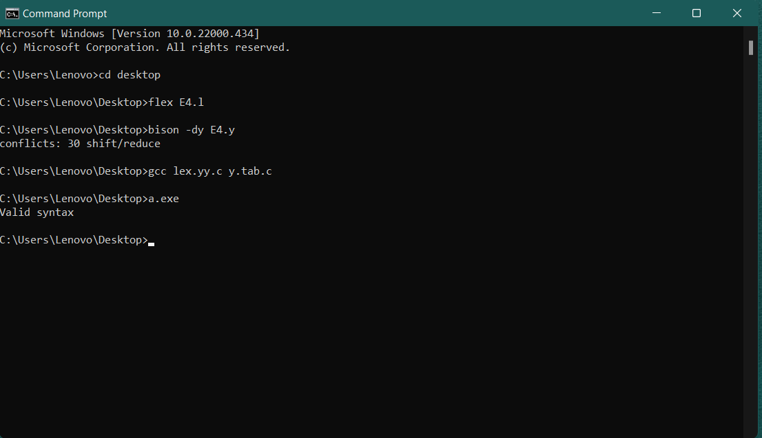

Aim E5: Write YACC specification to recognize strings that can be accepted by grammar of the form: an b n c, n>=1

Program:
Lexical Analyzer Source Code :
%{
#include "y.tab.h"
%}
%%
[aA] return A;
[bB] return B;
[cC] return C;
\n return NL;
. return yytext[0];
%%
int yywrap()
{
return 1;
}
Parser Source Code :
%{
#include<stdio.h>
#include<stdlib.h>
int yyerror(char* msg);
int yylex(void);
%}
%token A B C NL
%%
stmt: A S B C NL {printf("Expression is valid\n");
exit(0);}
;
S: A S B
|
;
%%
int yyerror (char *msg) {
printf ("Expression is invalid.\n", msg);
}
int main(){
printf("Enter an Expression: ");
yyparse();
}
Input:
- aabbc
- aaaabbbbc
- abbc
- aabbcc
- aaabbbc

Output:
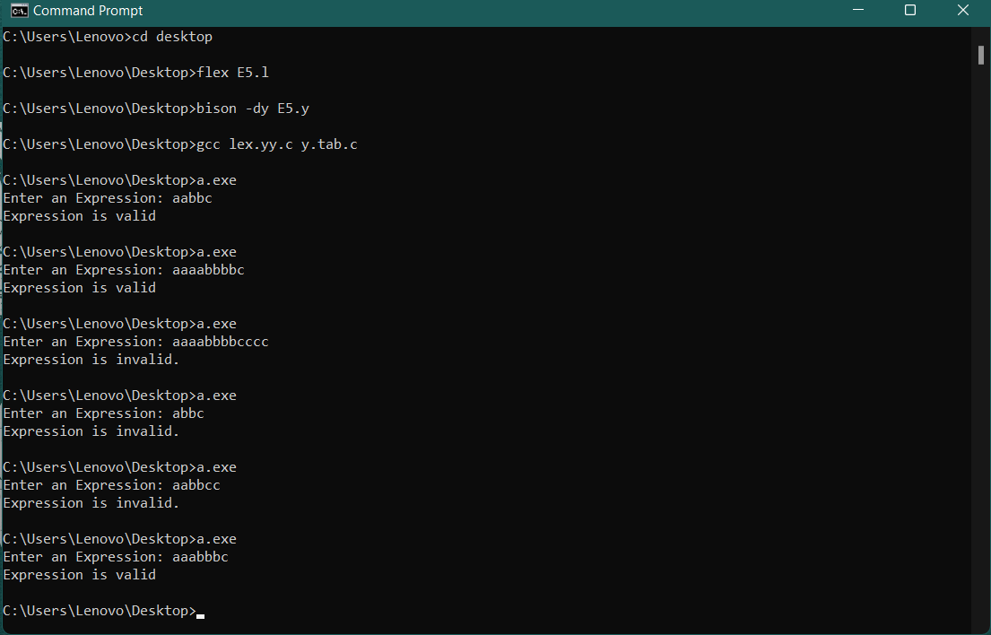

Aim E6: Write YACC specification to recognize strings that can be accepted by grammar of the form: {L= a n b 2n c, n>=1 }

Program:
Lexical Analyzer Source Code :
%{
#include "y.tab.h"
%}
%%
[aA] return A;
[bB] return B;
[cC] return C;
\n return NL;
. return yytext[0];
%%
int yywrap()
{
return 1;
}
Parser Source Code :
%{
#include<stdio.h>
#include<stdlib.h>
int yyerror(char* msg);
int yylex(void);
%}
%token A B C NL
%%
stmt: A S B B C NL {printf("\nExpression is valid.\n");
exit(0);}
;
S:A S B B
|
;
%%
int yyerror (char *msg) {
printf ("\nExpression is invalid.\n", msg);
}
int main(){
printf("Enter an Expression: ");
yyparse();
}
Input:
- aabbbbc
- aabbc
- abc
- abbc
- aaabcc
Output:
